#1 Cancel with cover.

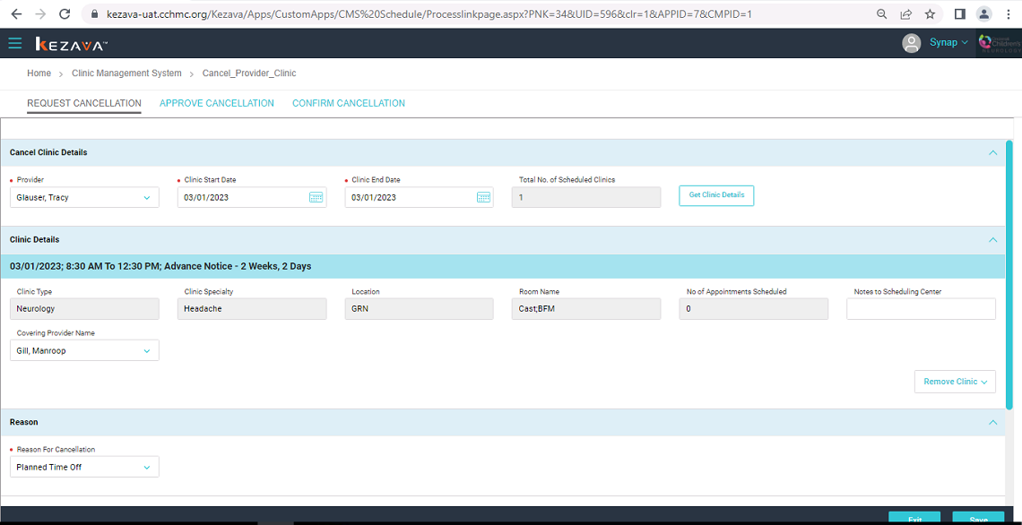

Cancel inprogress available in clinic calendar

Add As Covering Provider not available in RAD and Calendar

After confirm.

Both covering provider and cancel available in calendar and add as covering provider in RAD

#2

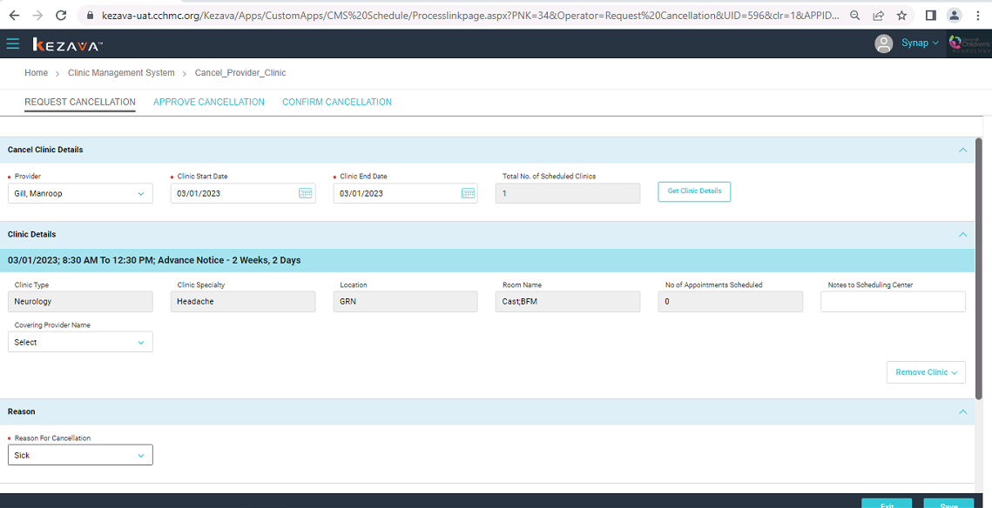

Cancel provider clinic and add as covering provider-cancel inprogress available in calendar

After confirm

Both cancel and add as covering provider – cancel available in calendar

#3.

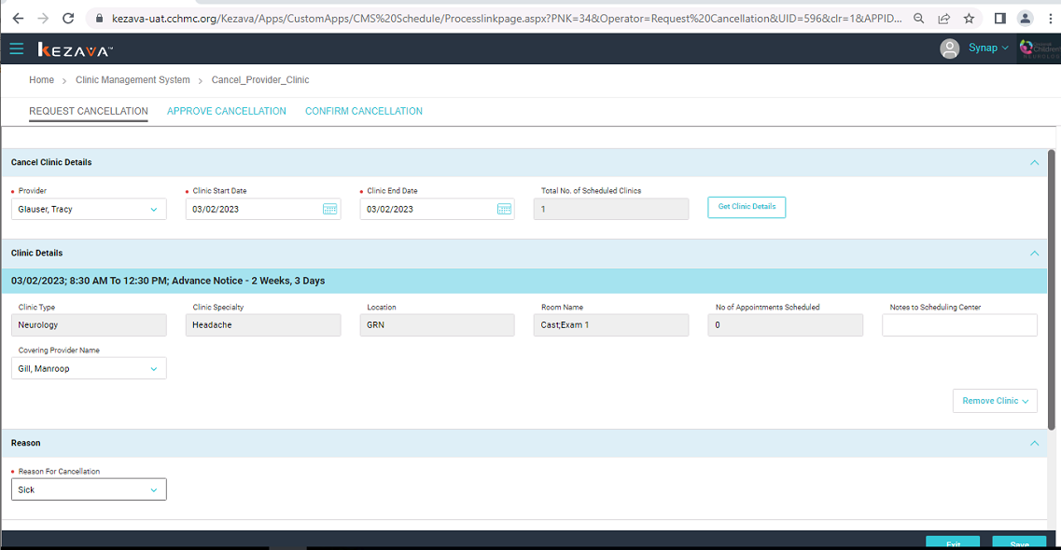

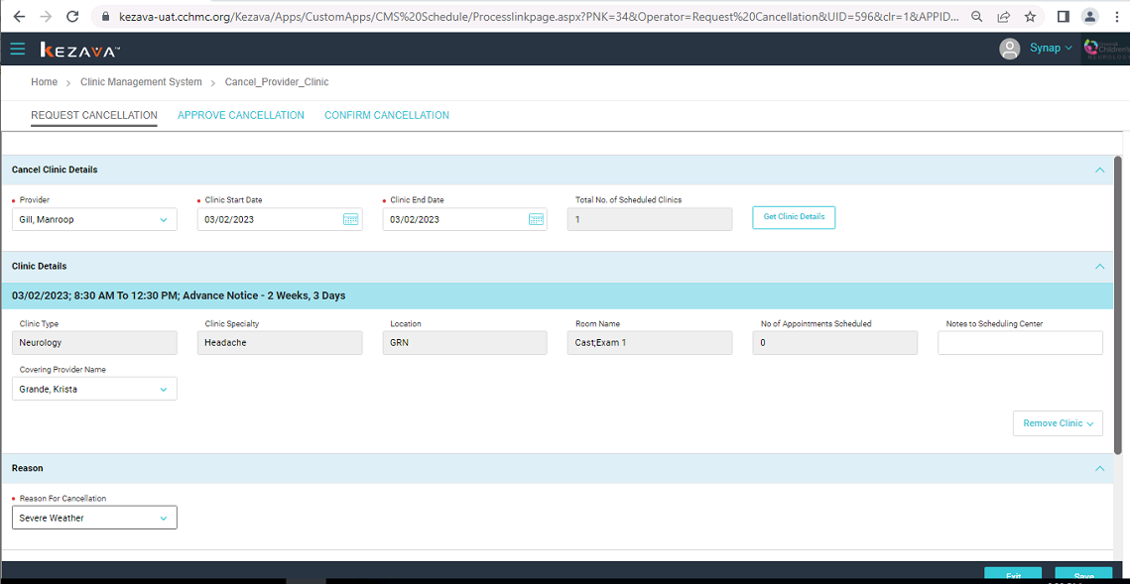

Cancel provider and add as covering provider – cancel inprogress

After confirm

Cancel provider and add as covering provider – cancel provider and add as covering provider

Cancel with cover and cancel and add same location

Cancel provider – cover cancel -> Add provider clinic

Cancel with cover and cancel and add different location

Both cancel and add available in calendar

Cancel with cover and cancel and add different time same location

Both cancel and add available in calendar